- Write a SQL query that writes todays date and time in the following format
Todays date is 04 DEC 2010 17:15:23
1 Mark
SELECT to_char(sysdate, ‘DD MON YYYY HH24:MI:SS’) from dual;

- What is a Nested block? What are the benefits of using Nested blocks?
1 Mark
A block within a block. It enables you to create a scope for all your variables, exceptions and modules in that block. Exceptions within a nested block can be handled without halting the program. After exception handling, control passes to the parent block.

- Write the syntactically correct code to initialize at least three variables of different data types. One of the data types should be a date. Initialize all the variables to appropriate values
1 Mark
DECLARE
V_DATE DATE := to_date(‘04/JUN/12’, ‘DD/MON/YY’);
V_NUMBER NUMBER(10) := 1234567890;
V_STRING VARCHAR2(10) := ‘String’;
BEGIN
NULL;
END;

- What purpose does the word PRAGMA serve?
1 Mark
We can use the PRAGMA**, EXCEPTION_INIT to bind an
error code to a user defined exception. A pragma is a compiler directive that is processed at compile time, not at run time.

Pragma designates an instruction to the compiler. It is used for defining ones own exceptions using autonomous transactions.

- Name three built in PL/SQL packages and describe what they are used for
3 Marks
Dbms_output: To control console output, which is usually visible to database developers.
UTL_SMTP: To control the sending of emails from inside the database.
UTL_XML: To control the parsing of data into XML format.
Dbms_alert: To control asynchronous messaging in the database
- (a) What is a CURSOR in PL/SQL. (1 Mark)
(b) What is the difference between an explicit cursor and an implicit cursor. (2 Marks)
(c) Describe the steps necessary to create and use a cursor. (3 Marks)
Do NOT talk about the cursor FOR Loop in your answer.
6 Marks
A cursor is used whenever we are handling multiple records with PLSQL. It is a pointer to the CURrent Set Of Records.
An implicit cursor is used when we use DML statements such as SELECT…INTO, INSERT, UPDATE, DELETE. It is created and run by the system, not the user, so it is implicit.
An explicit cursor is used when the user wishes to work with multiple records with more control. It is declared by using CURSOR c_cursorname IS SELECT …; It can then be used in a FOR LOOP, or opened, fetched into a variable, manipulated then closed.
DECLARE
cursor c1 is select custno, custfirstname,
custlastname, custbal
from customer
where custbal > 100;
--v_cust_no customer.custno%TYPE;
--v_custfirstname customer.custfirstname%TYPE;
--v_custlastname customer.custlastname%TYPE;
--v_custbal customer.custbal%TYPE;
-- or
r1 c1%ROWTYPE;
BEGIN
open c1;
LOOP
fetch c1 into r1;
EXIT WHEN c1%NOTFOUND;
dbms_output.put_line('Records in the cursor = '||c1%ROWCOUNT);
END LOOP;
close c1;
END;

The steps are DECLARE-OPEN-FETCH-CLOSE.

7.
The following code has a number of syntax errors. You are asked to identify the errors and indicate why the syntax is wrong.

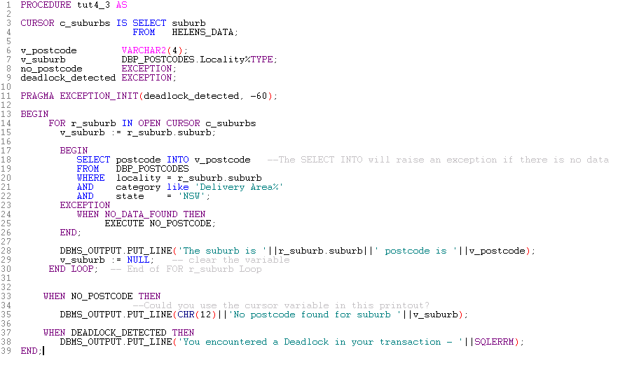
Line 7: %type not %rowtype
Line 14: cursor must be opened prior to cursor FOR LOOP
Line 15: forgot the word LOOP
Line 25: Execute should be THEN RAISE

